- Luke 1:8-12
- Where did Zechariah enter and what was he doing in this passage?
- Exodus 30:1-10, Exodus 40:5
- Where is the “altar of incense” located according to Exodus?
- Who meets there?
- Who appeared to Zechariah at the “altar of incense”?
- How did Zechariah respond?
- Revelation 8:1-4, Tobit 12:12-15
- List some of the things “angels” do according to Tobit and Revelation?
- Can you name at least three angels who are mentioned in the Bible by name?
- What else is present directly behind this “altar” according to Exodus?
- Notice this story starts with a priest standing at the “altar” before the “ark of the covenant” and a message from an angel, and in this same chapter it will soon transition to another angel scene followed by Elizabeth standing before Mary and the infant Jesus in her womb, could there be any type of relationship between the two settings, reflect and please share your thoughts?
- Luke 1:13
- How does the angle comfort Zechariah?
- If you have a footnote for this verse go to it, and if not Google the name John in Hebrew to learn its meaning and share its meaning with the group.
- St. Bede (672 AD – 735 AD) Homilies on The Gospels Section 2.19
“We must note that the angel bore witness to the grace about which he had come to give the good news, not only by the power of the words which he brough forward, but also by the point in time and the location of the place in which he appeared. He appeared at the time when the priest was making an offering to express the fact that he was proclaiming the coming of the true and eternal high priest, who would be the true sacrificial offering for the salvation of the world. He stood beside the altar of incense to teach that he had come as the herald of a new covenant. There were two altars in the temple, which expressed the two covenants in the church. The first, the altar of burnt offerings, which was plated with bronze and was situated in front of the doors of the temple, was for the offering up of victims and sacrifices. It signified the fleshly-minded worshipers of the old covenant. Then there was the altar of incense, which was covered with gold and set near the entrance of the Holy of Holies, and was used to burn fragrant gums. This signified the interior and more perfect grace of the new covenant and its worshipers.”
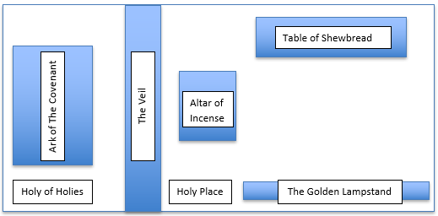
Outer Courtyard
Altar of Burnt Offerings
Laver

- Reflect for a moment on St. Bede’s writings and share something that stands out to you with the group.
- Catechism 331-336
- Share something that stood out to you in today’s study.

